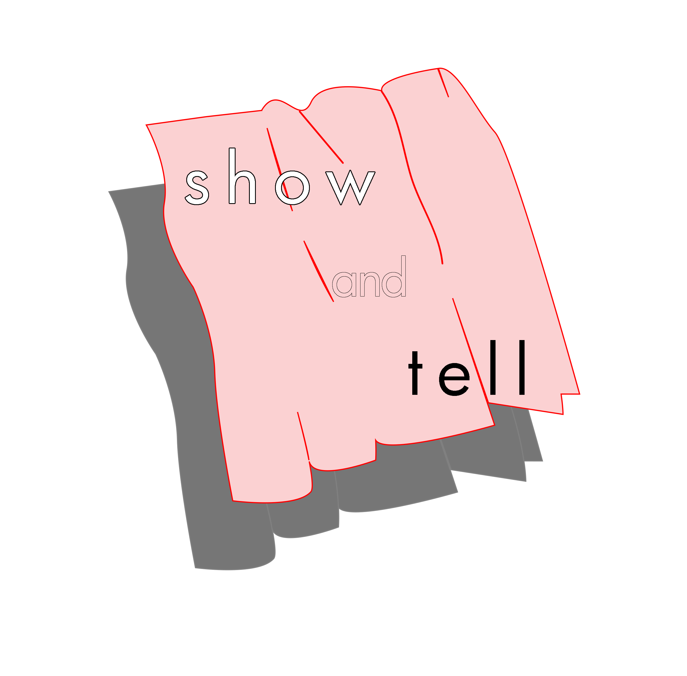
[2021 showandtell Non-profit Visual Arts Exhibition Space Operator Incubation Program Open Call ]

Name(team)
Email
Website
SNS

S H O W | what do you want to show? [operating plan]
 | -
T E L L | what do you want to tell? [what is artist run space?]
 | -

Please send this document to show_and_tell@naver.com with one of your representative practices

For more information, please visit our website: www.showandtell.kr
Contact: Yuna Nam <operator-1> yunayunarang@naver.com / Jihoon Son<operator-2> cold0111@naver.com

